**Title:** *Landscape context mediates the effect of shortening fire intervals on successional trajectories in boreal systems*

**Abstract:**

Warming temperatures in the boreal have been linked to increased frequency and severity of wildfires, and time intervals between fires have decreased from 50-100 years to 10-15 years within the last three decades in some areas. Shortening fire intervals have been shown to drive changes in successional pathways in boreal forests via seedbank limitation, but the role of variability in topography in promoting successional divergence remains unclear. While postfire succession in upland boreal black spruce forests is well understood, the effect of varying topography on the impact of multiple short-interval fires remains unclear. To investigate how landscape variability alters postfire successional trajectories under shortening fire intervals, we established plots across a mosaic of fire histories (1-3 fires in 70 years) in two sites in Interior Alaska with differing hydrology. We compared regeneration of conifers, deciduous trees and shrubs, and graminoids as well as soil carbon and nitrogen across unburned controls and stands experiencing one, two or three fires in 15-year intervals in an upland site (drier) and a lowland site (wetter). All stands were originally dominated by black spruce (*Picea mariana*), and at both sites, black spruce regeneration was significantly lower following three fires, compared to unburned stands and stands burned once. In the wetter lowland site, less organic soil was consumed by fire and presence of black spruce persisted until two fires, indicating local topography may initially drive successional divergence via differences in substrate consumption. Deciduous regeneration differed between two sites after three fires, with paper birch (*Betula neoalaskana*) dominating in upland sites and willow (*Salix spp.)* and aspen (*Populus tremuloides*) in lowlands. Results of this study offer strong empirical evidence of the divergence of boreal successional trajectories from previous historic norms and indicate the importance of examining the role of spatial heterogeneity on the impact of multiple disturbances.

**I. Introduction**

Increasing temperatures have been linked with global increases in the frequency and intensity of wildfires, sparking concern that changing fire regimes will lead to rapid ecosystem change if local resilience is exceeded (Young et al. 2017). Fire return intervals of < 20 years are becoming increasingly common across the last six decades (Kasischke et al. 2010, Brown & Johnstone et al. 2012, Johnstone & Chapin 2006A, Johnstone & Chapin 2006B). Short fire intervals (< 30 by boreal standards) have been shown to alter successional pathways through seedbank and substrate consumption, and theoretical model outputs suggest that an increase in area reburned in short intervals may lead to a shift in forest community composition from conifer-dominated stands to deciduous shrublands and grasslands (Johnstone et al. 2009, Hoy et al. 2016). Initial empirical observations of reburning in boreal system indicate an increased presence of deciduous species after the second fire alongside a decline in conifers, but to date research has been limited to single reburn events (2 fires in sequence). While this is valuable, an increase in fire frequency means repeated short interval events – and the cumulative effects of three or more fires remains unknown, limiting our ability to make inferences regarding future boreal forest community composition. There is no information on how forested ecosystems respond to such an acceleration of fire. Furthermore, research on short interval fires has almost entirely focused on conifer resilience, but the effects of short interval fires on deciduous species is unknown. Given the increasing evidence for a shift to a boreal forest dominated by deciduous species, understanding the effects of multiple fires on the emerging deciduous dominated forest structure will be essential to understanding and predicting the impact of ongoing environmental and climatic change in high-latitude environments.

TConventional understanding of successional trajectories in serotinous boreal systems identifies self-replacement as the most prevalent post-fire successional pathway: for example, black spruce (*Picea mariana*) has typically been found to self-replace immediately after fire, remaining the dominant canopy cover before and after disturbance. Short-interval fires appear to However, species-replacement has become more common in boreal forests with increasing fire frequency: the transition of dominance from conifers to birch and other deciduous species following two consecutive fires has been well documented in Interior Alaska (Johnstone et al. 2004, CITE), the Yukon Territory (Brown..), etc. Furthermore, species distribution models have shown that the climatic niche conditions satisfying physiographic requirements of both black spruce and deciduous species may expand with warming temperatures, potentially creating more opportunities for successional divergence (Kurkowski et al. 2008).

[Add in seed paragraph]

Rapidly increasing fire frequency has effects beyond the direct depletion of the canopy seedbank. The role of burn severity in promoting deciduous dominance through consumption of soil organic layer has been well documented in boreal Interior Alaska, but primarily in the gently sloped upland environments typical in the Interior. Flatter, lowland sites remain underexamined, though they represent a significant proportion of the Interior. The role of wetter conditions characteristic of lowland sites in altering post-fire succession in comparison to upland sites remains unknown, in part because of their historic unlikelihood to burn. Warming temperatures may begin to overwhelm fuel moisture limitations to burning, making it crucial therefore to understand postfire successional trajectories in lowland sites.

This study characterizes post-fire regeneration following a rapid increase in fire frequency from the 19XX to present. We compare forest resilience across a gradient of 1-3 fires (return interval from XX to XXX) in both upland and lowland forests. We hypothesis that repeat, short interval fires will reduce conifer density via a reduction in the seedbank and organic layer thickness, favoring deciduous trees, as shown in other systems – but that continued short interval fires will similarly disfavor traditional secondary succession communities in favor of primary succession communities. We anticipate that dry, sloped sites may be less resistant to this transition due to greater soil consumption in each fire.

**II. Methods**

**Site Selection**

We established 50 individual 20x20m plots in two sites (total n = 50) in Interior Alaska in natural mosaics of stands differing in recent fire history. Each plot has experienced between one to three fires with full aboveground canopy mortality in the last 60 years, as confirmed by aerial photography (Supplement 1). Eight unburned plots were established as controls. Plots were established a minimum of 50 meters apart, and a minimum of 50 meters away from unburned legacies. Plots were stratified evenly? between an upland site and a lowland site. The upland site represents well drained boreal forest; the lowland a flatter, more poorly drained location. Both are on the northern edge of the discontinuous permafrost zone; with nearby unburned black spruce communities have shallow permafrost (data not shown). Vegetation in both areas is/was dominated by black spruce with occasional birch or trembling aspen, and in mature stands the mineral soil is covered with a thick moss mat. Sites were chosen based on accessibility by road and presence of multiple burn histories in close proximity. All sites burned in XXX or XXX, ensuring a similar time since fire for comparison.

Sites were established across a range of slopes and aspects (Fig. X). Upland plots receive an average of XX inches of rainfall per year, while lowland plots receive XX.

Burn history was established based on both historic aerial photographs from XXX source, and modern remotely-sensed fire perimeters from XX source.

Size of plots, slope and aspect taken from XXX source…

Presence of spruce prior to the burn sequence was verified by sampling XXX downed woody debris of various ages..

**[Table of fires, dates, sizes (might do as sites, with the associated fire at each site)]**

Soils reference

**Field Sampling**

Stems and seedlings were counted in each plot; where density precluded counting over the entire 400m2, a randomly selected subset (100 or 200 m2) was counted. Canopy health, presence of browse, and understory species were noted for each stem counted above DBH. For asexual reproducers such as willow and aspen, each individual stem in a given clump was counted and then clumps were pooled and treated as individual trees.

You going to use adventitious root data here? Percent cover of soil data would be valuable too, since it has % organic.

Organic layer depth was measured at the center and at each corner of each plot in centimeters.

Presence and abundance of soil cover was estimated across 1-meter subplots at each corner of each site, along with presence and abundance of understory species.

**Data Analysis**

All analyses were performed in R version (CHECK) (R Development Core Team, 2014) and reported means include +/- 1 standard error. All dependent variables were log-transformed to meet assumptions of normality. Because our plots are clustered by design to take advantage of natural experimental conditions, spatial autocorrelation among plots was assessed by [EXPLAIN]. We found no evidence of spatial autocorrelation (Table #) but accounted for the grouping of plots in sites by including site as a random effect in linear mixed effect models (LME).

Recruitment and regeneration differences at each site were determined by initial one-way analysis of variance (ANOVA) tests, followed by Tukey multiple pairwise-comparisons.

We used LME models to determine the effect of substrate consumption on regeneration abundance of each species. Each model included an interaction between the fixed effects of fire history and site. The best structure for each model was selected based on the lowest AIC value and F-test comparisons (Table #).

**III. Results**

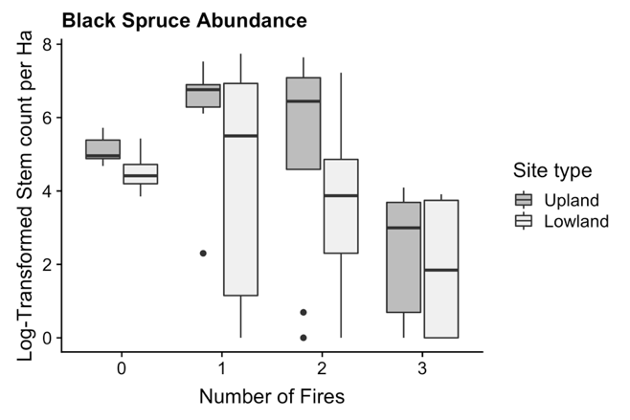

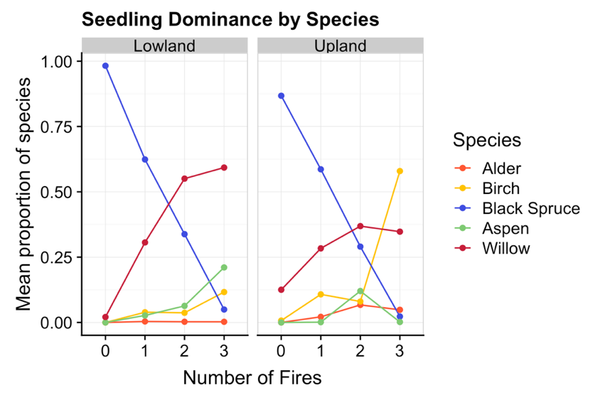

**Figure X. Average proportion of species present at each burn history between upland and lowland sites.**

**Seedling regeneration**

Black spruce is the dominant seedling present in unburned plots, representing 98% of upland seedling species and 86% of lowland seedling species but declines in relative proportion with increasing number of fires to X% and X% in uplands and lowlands respectively. Willow seedling dominance increases across fire history in both sites initially, but a divergence occurs between upland and lowland plots after two fires: willow assumes dominance in twice- and thrice-burned lowland plots but willows never represent more than 50% of seedlings in upland sites, and in fact declines between twice- and thrice-burned plots. Proportions of birch seedlings increase significantly (p-value = X) between twice- and thrice-burned upland plots by a factor of X.

|  |  |  |  |  |  |  |
| --- | --- | --- | --- | --- | --- | --- |
| Setting | Treatment | Species | Seedling Density | Seedling SD | Stem Density | Stem SD |
| Lowland | 0 | Aspen | 0 | 0 | 0 | 0 |
|  |  | Birch | 0 | 0 | 0 | 0 |
|  |  | Black spruce | 1.6225 | 0.605 | 0.97 | 0.42559762 |
|  |  | Willow | 0.0275 | 0.055 | 0.0075 | 0.005 |
|  | 1 | Aspen | 0.471428571 | 0.670110154 | 0.00166667 | 0.00408248 |
|  |  | Birch | 0.742857143 | 0.752456295 | 0.09166667 | 0.09780934 |
|  |  | Black spruce | 9.571428571 | 4.623748222 | 0.00833333 | 0.02041241 |
|  |  | Willow | 5.342857143 | 3.859990131 | 0.025 | 0.01843909 |
|  | 2 | Aspen | 2.033333333 | 1.540995349 | 0.01 | 0.00774597 |
|  |  | Birch | 0.966666667 | 0.27325202 | 0.07916667 | 0.05774224 |
|  |  | Black spruce | 10.36666667 | 6.321286789 | 0.0025 | 0.0041833 |
|  |  | Willow | 15.43333333 | 5.153122031 | 0.12 | 0.24091492 |
|  | 3 | Aspen | 1.9 | 1.089342309 | 0.266875 | 0.19484311 |
|  |  | Birch | 0.728571429 | 0.540722621 | 0.04 | 0.03664502 |
|  |  | Black spruce | 0.342857143 | 0.161834719 | 0.00375 | 0.00443203 |
|  |  | Willow | 7.985714286 | 7.635318935 | 0.246875 | 0.16881811 |
| Upland | 0 | Aspen | 0 | 0 | 0 | 0 |
|  |  | Birch | 0.0075 | 0.015 | 0.015 | 0.00912871 |
|  |  | Black spruce | 0.675 | 0.19485037 | 0.6575 | 0.33819373 |
|  |  | Willow | 0.11 | 0.111654228 | 0.05125 | 0.03727712 |
|  | 1 | Aspen | 0.028571429 | 0.075592895 | 5.00E-04 | 0.00158114 |
|  |  | Birch | 4.164285714 | 6.644842253 | 0.208 | 0.32975749 |
|  |  | Black spruce | 10.45 | 8.421698166 | 0.0065 | 0.01546501 |
|  |  | Willow | 8.957142857 | 10.43118037 | 0.1 | 0.13274872 |
|  | 2 | Aspen | 0.065 | 0.11351526 | 0.010625 | 0.01781602 |
|  |  | Birch | 0.91875 | 1.469095324 | 0.300625 | 0.28895671 |
|  |  | Black spruce | 2.45 | 4.66268776 | 0.000625 | 0.00176777 |
|  |  | Willow | 4.7575 | 5.487551497 | 0.123125 | 0.17854446 |
|  | 3 | Aspen | 0.003333333 | 0.008164966 | 0.00166667 | 0.00408248 |
|  |  | Birch | 5.065 | 9.584898017 | 0.49583333 | 0.64749839 |
|  |  | Black spruce | 0.153333333 | 0.232005747 | 0 | 0 |
|  |  | Willow | 0.7 | 0.670134315 | 0.10166667 | 0.06524314 |

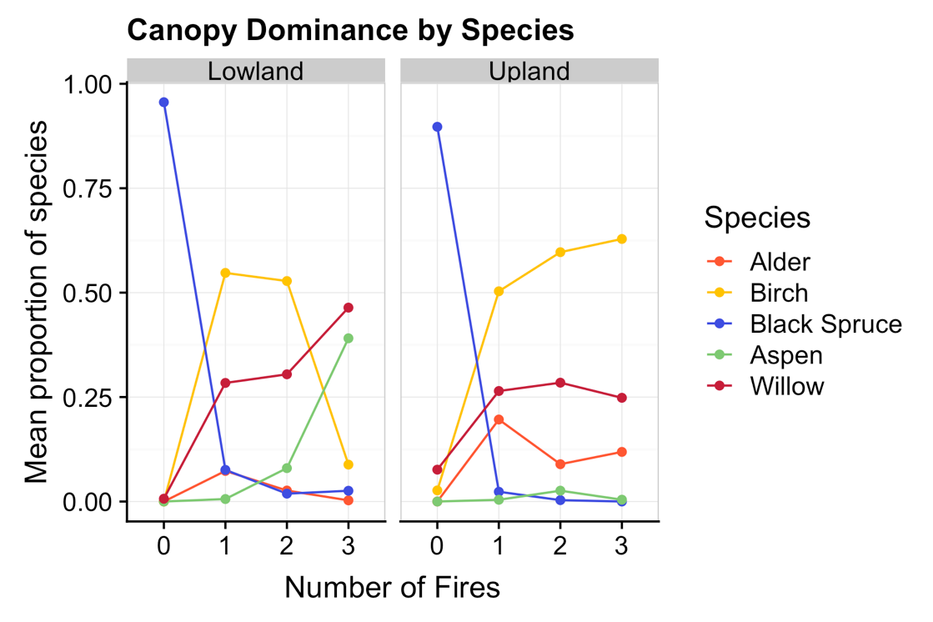

**Figure X. Average proportion of individual species across each fire history between upland and lowland sites.**

**Canopy Dominance**

In unburned sites in both upland and lowland plots, the dominant canopy species is black spruce, with minimal relative presence of birch or willow. Black spruce dominance decreases significantly after one fire in both upland (insert p-value) and lowland plots (p-value = 1.624e-05). Upland plots see an increase in the proportion of birch, willow and alder after two fires, with birch assuming dominance (representing more than 50% of the species present on a plot) after three fires. Lowland plots see a similar increase in birch and willow, with willow and poplar becoming dominant after the third fire (Figure X). Birch presence in lowland plots is significantly different between twice- and thrice-burned plots (p-value), decreasing in proportion by a factor of X.

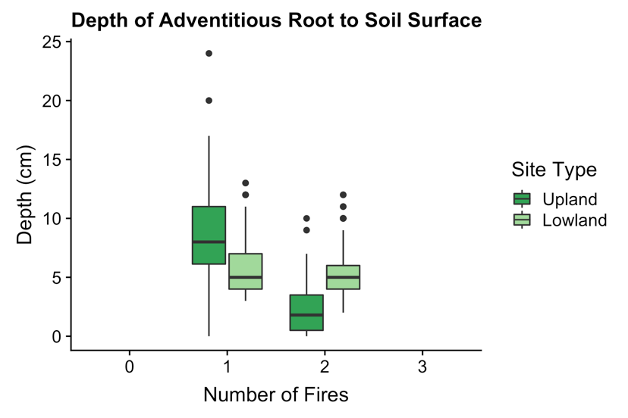

**Figure X. Depth in centimeters from highest adventitious black spruce roots to soil surface across fire history.**

**Adventitious roots**

Adventitious roots were only available to sample in once- and twice-burned plots. Depth from adventitious root to current soil surface ranged from 0 to 24 cm in once-burned upland plots, and 3 to 7 cm in once-burned lowland plots. The range of adventitious root depth in upland plots shrank between once- and twice-burned plots by a factor of 2.4, ~~indicating the homogenizing effects of the second fire (insert which one that was) in upland fires~~. Adventitious root depth in lowland plots did not differ significantly (p=0.1064) between once-burned and twice-burned plots.

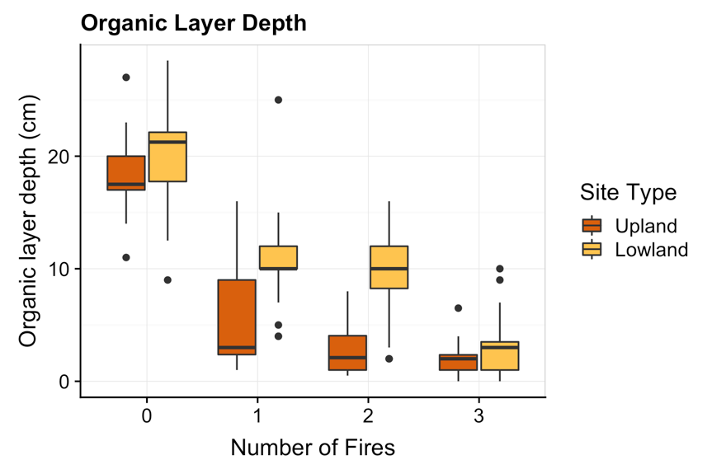

**Figure X. Depth of Organic Layer (cm) between Upland and Lowland Sites according to burn history.**

**Soil Consumption**

Unburned organic-layer depths ranged from 11 to 27 cm in upland plots and from 9 to 28.5 cm in lowland plots with respective averages and standard deviations of 18.35 cm +/- 3.4 cm and 20.2 cm +/- 4.5 cm. In once-burned sites, organic-layer depths ranged from 1 to 16 cm in uplands and from 4 to 25 cm in lowlands, averaging 5.7 +/- 4.7 cm and 10.91 +/- 3.6 cm respectively. Twice-burned plots had upland organic-layers between 0.5 and 8 cm deep and lowland layers between 2 and 16 cm with averages of 3 +/- 2.2 cm and 9.8 +/- 4 cm. Finally, thrice-burned organic-layers fell between 0 and 6.5 cm in uplands and 0 and 10 cm in lowlands, averaging 1.9 +/- 1.4 cm and 2.9 +/- 2.3 cm. Lowland organic-layers were thicker than upland layers regardless of burn history by a factor of 1.6, and the difference between the two sites was largest in twice-burned plots where lowland organic-layers were larger by a factor of 3.2.

**Model Results**

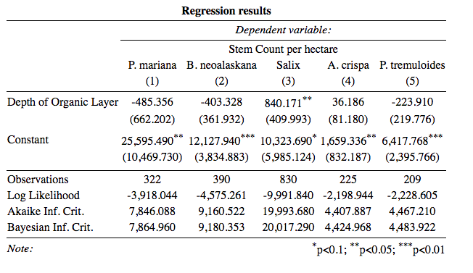

Results from the linear mixed model indicate a significant association between organic layer depth and black spruce regeneration after controlling for the variation found between number of fires and site (p-value = < 2e-16).

**Discussion**

**Seedling Regeneration**

The majority of black spruce recruitment has been found to take place within 3 to 10 years after fire, indicating our results should capture the full extent of black spruce reestablishment (Johnstone et. al 2004). Furthermore, studies like Johnstone et. al 2004 have found that stand composition 5 years postfire is strongly predictive of composition 20 to 30 years out, indicating the importance of initial recruitment rates and trends in determining decadal successional pathways. Seedling composition of our plots 15 years postfire may therefore be taken as strongly inferential of future stand compositional communities. Comparing our seedling recruitment trends to those found in single postfire successional studies, or even single reburn successional studies, the decline in black spruce found in short-interval reburns becomes especially dramatic: Johnstone et. al 2004 found black spruce to be 98% of all postfire tree seedlings after a single fire, with stem densities between 1-9 stems per square meter.

**Canopy Regeneration**

**Soil Consumption**

The divergent trend in organic layer consumption indicates the difference in fire effects between the upland and lowland sites: less organic layer is consumed in lowland sites with one or two fires, indicating that wetter conditions may mediate the effect of even high-severity fires. This variation between sites indicates that local heterogeneity in topography and climate may facilitate resilience in black spruce stands, up until a certain threshold.

**Now a place to go broader – bring back that primary vs. secondary discussion idea. Also bring in the broader context of fires in the boreal, etc.**

**Conclusions**